THE USER MANUAL -

1. This is the splash screen which appears for 2 seconds, when you open the app.

1. This is the main screen, it gives you various options like –

* Scan a document
* QR scan
* Convert
* My files
* Gallery

The three dots button on the top right corner contain the about us and the privacy information.

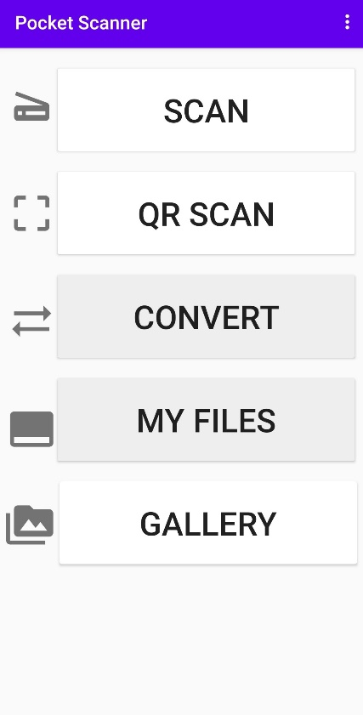

1. When you click on the scan button the camera starts and after capturing the image you get an option to crop and apply various filters.

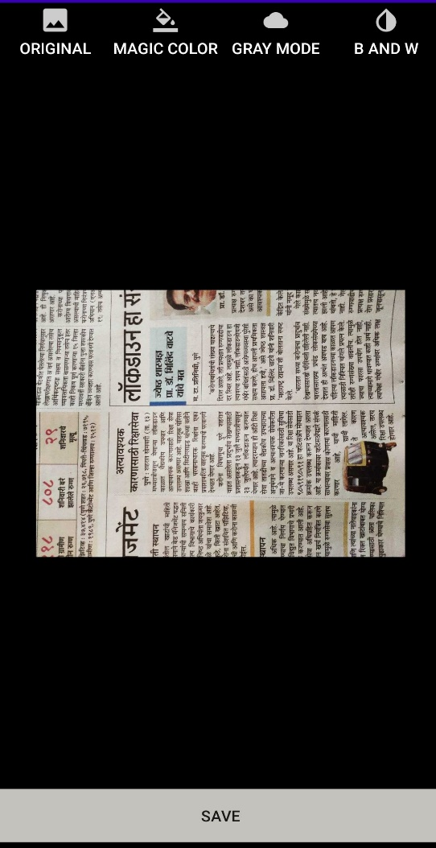

1. The QR scan lets you scan the QR code and takes you to the website.

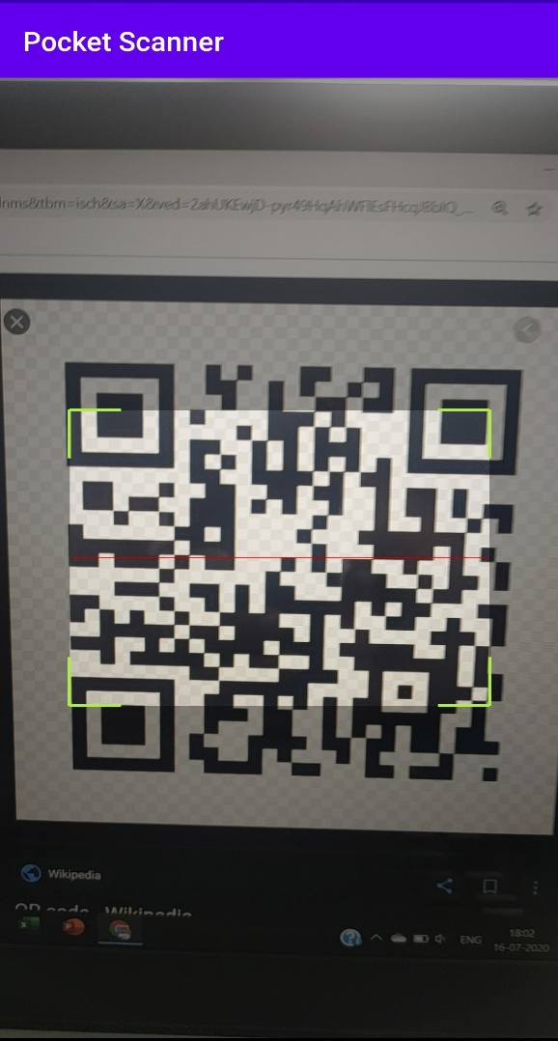

1. After clicking on the convert button, it lets you pick an image from the gallery and after you select the image it gets converted into a pdf.

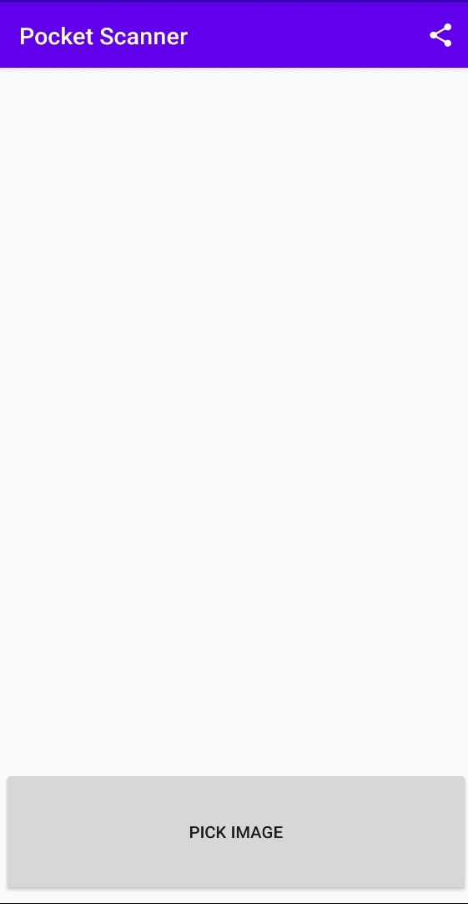 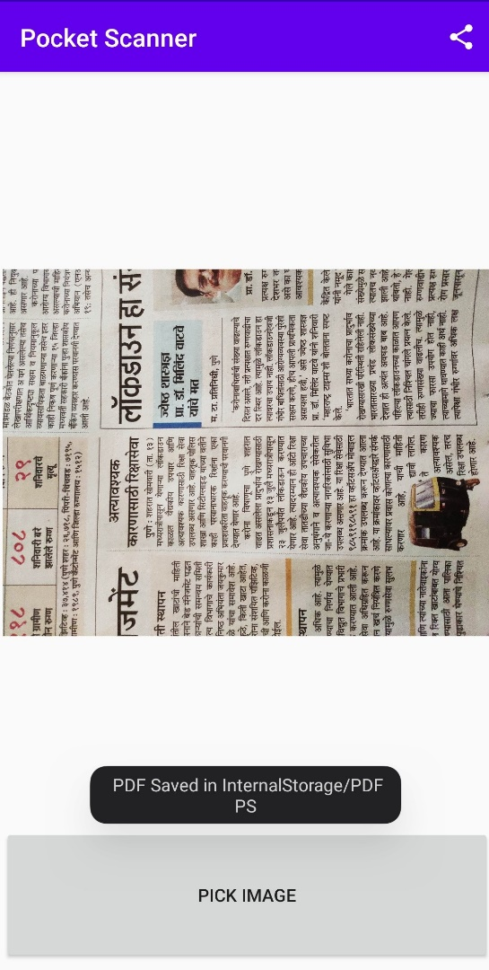

1. The My Files button shows you your previous scanned images or files.
2. When you click on the Gallery button it lets you select an image and after the image is selected you can crop and the apply filters.

